Project: ________________________________________________________ |  | Manufacturer.:
Region: |  | Model No.:
Service: |  | Number of Units:
Equip. Tag Number(s)*: |  | Rev/Date/By: / /
GENERAL REQUIREMENTS
Equipment Capacity: kg (___tons) | Factory Testing: | Power Supply:
Method of Control: | Required Not Required | Voltage
Location of Control: | Field Testing: Not required | Phase
Equipment Location: | Required, functional and | Frequency
Indoors Outdoors | Performance
BRIDGE | TROLLEY | HOIST
Type: | Type: | Type:
Single Girder Double Girder | Top Running Underhung | Electric, Wire Rope
Top Running Underhung |  | Hand Operated, Chain
Service Class (ANSI): | Service Class (ANSI): | Service Class (ANSI):
A (standby) B (light) | A (standby) B (light) | H1 (standby) H2 (light)
C (moderate) D (heavy) | C (moderate) D (heavy) | H3 (standard H4 (heavy)
E (severe) F (continuous) | E (severe) F (continuous) | H5 (severe)
Speed cm per minute (fpm): | Speed cm per minute (fpm): | Speed cm per minute (fpm): to
Constant Speed | Constant Speed | Constant Speed Two Speed
Variable Speed Hand Operated | Variable Speed Hand Operated | Variable Speed
Motor kW (hp): | Motor kW (hp): | Motor kW (hp):
Main Runway Electric Conductors: | Electric Conductors: | Hook: See Crane Dimension Sheet
Bus Bar Festoon | Bus Bar Festoon | Hook Manufacturer:
Bridge Drive System (CMAA): | Cable Reel
A1 A2 A3
A4 A5 A6
SPECIAL REQUIREMENTS
Accessories: | Remote Controls: | Special Electrical Requirements:
Service Platform | Infrared, line-of-sight
Central Lubrication System | Frequency Modulated (FM)
OHSA Operating and Safety | Manufacturer:
Devices | Extended Grease Fittings
See Crane Data Sheet – Overhead Traveling Cranes for clearances, lift distances, and details.
* Equipment Tag Number shall conform to the Region’s Tagging Standard. Refer to Section 21 – Development and Maintenance of Asset Inventory and Tagging.
[DESIGN NOTE: Consultant to modify to chosen type of crane remote control above in the “Special Requirements” section (radio or pendant hard-wired)]

Project:
Region:
Equip. Tag No.*:
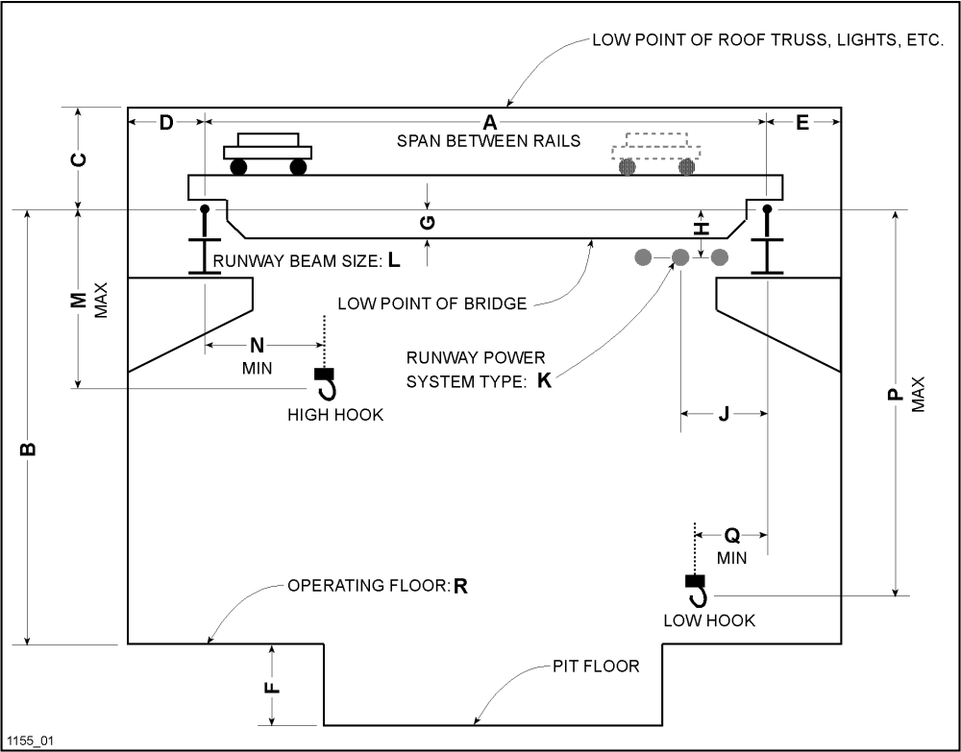

A: | E: | K:
B: | F: | L:
C: | H: | M:
D: | J: | P:

Project:
Region:
Equipment Name:
Equipment Tag Number(s)*: )
Type: Squirrel-cage induction meeting requirements of NEMA MG 1-2014
Manufacturer: For multiple units of the same type of equipment, furnish motors and accessories of a single manufacturer
Hazardous Location: Furnish motors for hazardous (classified) locations that conform to UL 674 and have an applied ULC listing mark
Motor Horsepower: | Guaranteed Minimum Efficiency at Full Load: percent
Voltage: | Guaranteed Minimum Power Factor at Full Load: percent
Phase: | Service Factor (@ rated max. amb. temp.): 1.0 1.15
Frequency: | Enclosure Type:
Synchronous Speed: rpm | Mounting Type: Horizontal Vertical
Multispeed, Two-Speed: | Vertical Shaft: Solid Hollow
/ rpm | Vertical Thrust Capacity (lb): Up Down
Constant kW (Horsepower) | Adjustable Speed Drive:
Variable Torque | ADJUSTABLE FREQUENCY DRIVE SYSTEMS.
Constant Torque | Operating Speed Range: to % of Rated Speed
Winding: One Two | Thermal Protection:
 | Space Heater: volts, single phase
 | Oversize main terminal (conduit) box for motors
Terminal for connection of equipment grounding wire in each
terminal box
Additional Motor Requirements: See Section 16220 – Motors 1 to 200 kW575 V
Special Features:

* Equipment Tag Number shall conform to the Region’s Tagging Standard. Refer to Section 21 – Development and Maintenance of Asset Inventory and Tagging.

